EXPERIMENT NO. 5
Interactive Dashboard Development using Tableau
Lab Report / Practical File

1. Aim
To design and develop an interactive business dashboard using Tableau Public for analyzing the Superstore Sales Dataset and presenting key performance indicators (KPIs) to support data-driven decision-making.

2. Purpose
Business Intelligence (BI) tools such as Tableau enable organizations to transform raw data into interactive dashboards and reports. Unlike static charts, dashboards allow users to filter, drill down, and explore data dynamically, helping managers monitor business performance and make informed decisions.
In this experiment, the provided Superstore Sales Dataset (9,800 records) is used to create an interactive dashboard featuring KPIs, charts, filters, and slicers that provide meaningful business insights.

3. Prerequisites
- Basic knowledge of data visualization concepts
- Familiarity with Tableau Public
- Understanding of data preprocessing and Exploratory Data Analysis (EDA)
- Cleaned Superstore Sales Dataset
- Basic knowledge of business metrics and KPIs

4. Software & Dataset Used
- Software: Tableau Public (latest version)
- Dataset: Superstore Sales Dataset.csv (9,800 rows × 18 columns)
- Key Fields: Order ID, Order Date, Customer ID, Segment, Region, Category, Sub-Category, Product Name, Sales
- Note: This version of the dataset contains Sales but does not include Profit, Quantity, or Discount columns. KPIs and charts are therefore based on available fields.

5. Procedure / Steps Performed

Step 1: Download and Install Tableau Public
Tableau Public was downloaded from public.tableau.com and installed successfully. A Tableau Public account was created for publishing the finished dashboard.
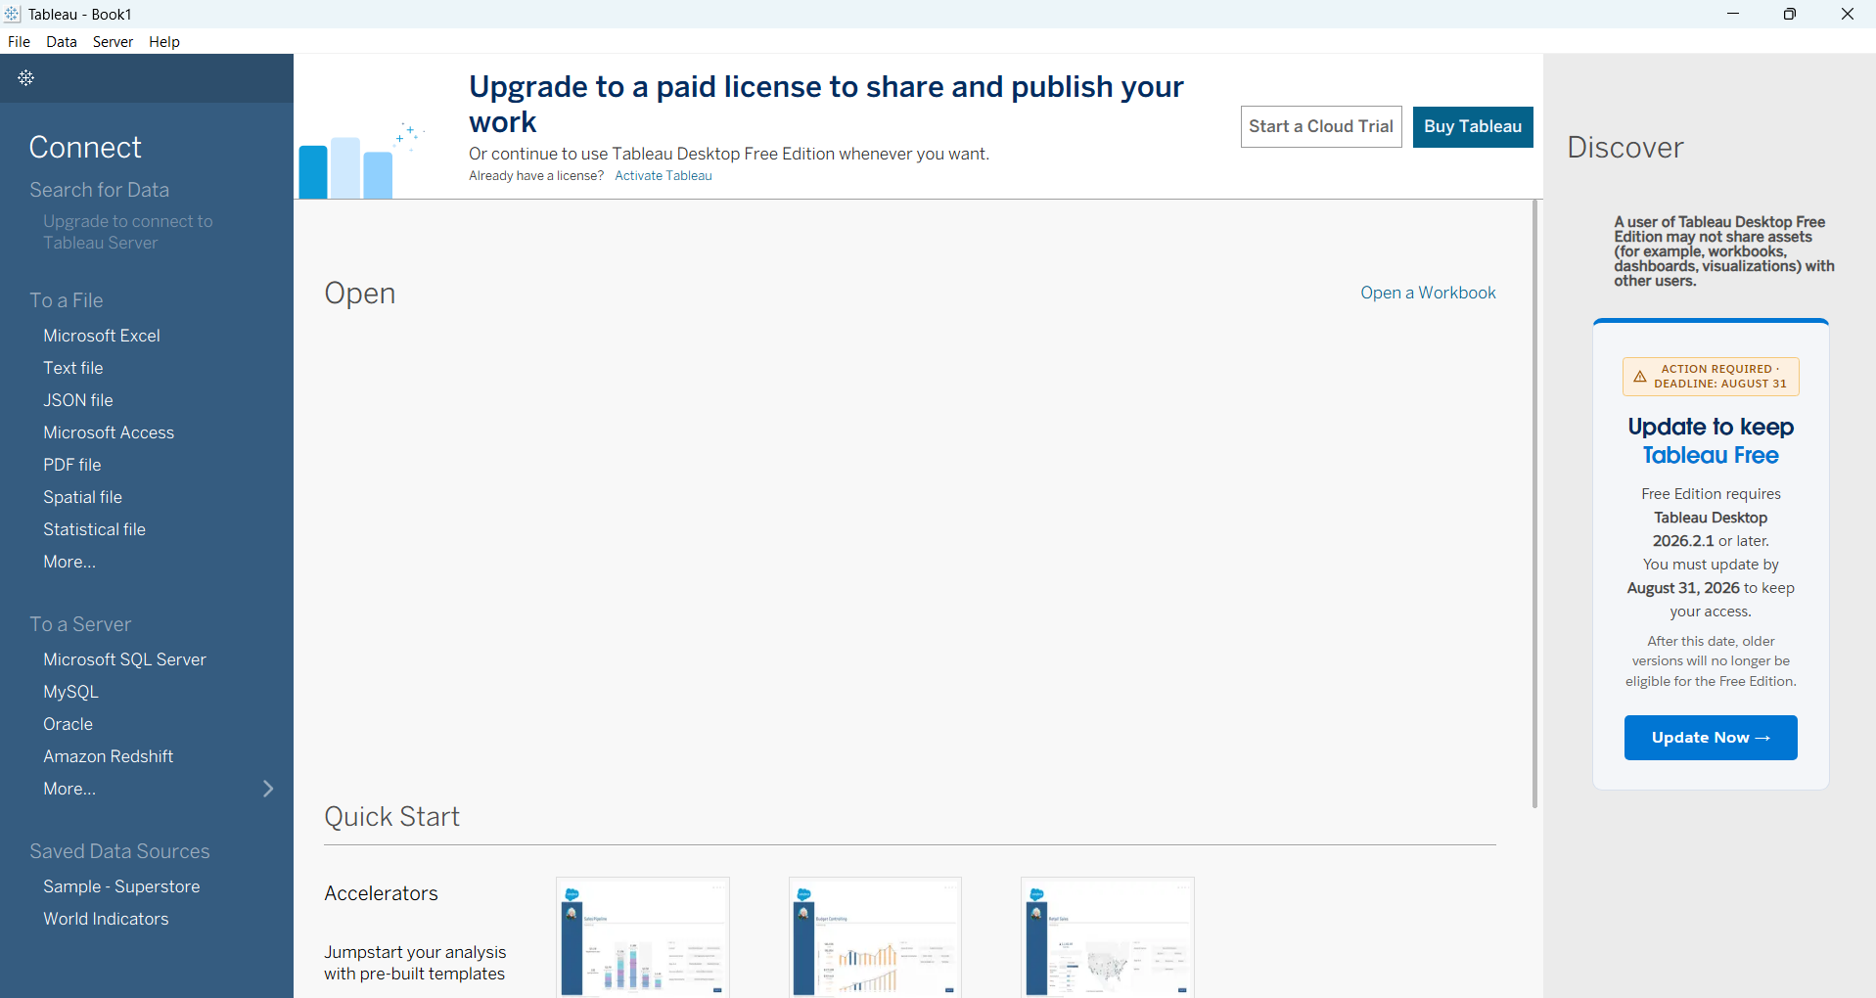
Figure 1: Tableau start screen after successful installation (Connect pane visible)

Step 2: Import the Dataset
The Superstore Sales Dataset.csv file was connected using the “Text file” connector. Tableau automatically detected the fields. Order Date and Ship Date were converted to Date type. Sales was confirmed as Number (decimal).
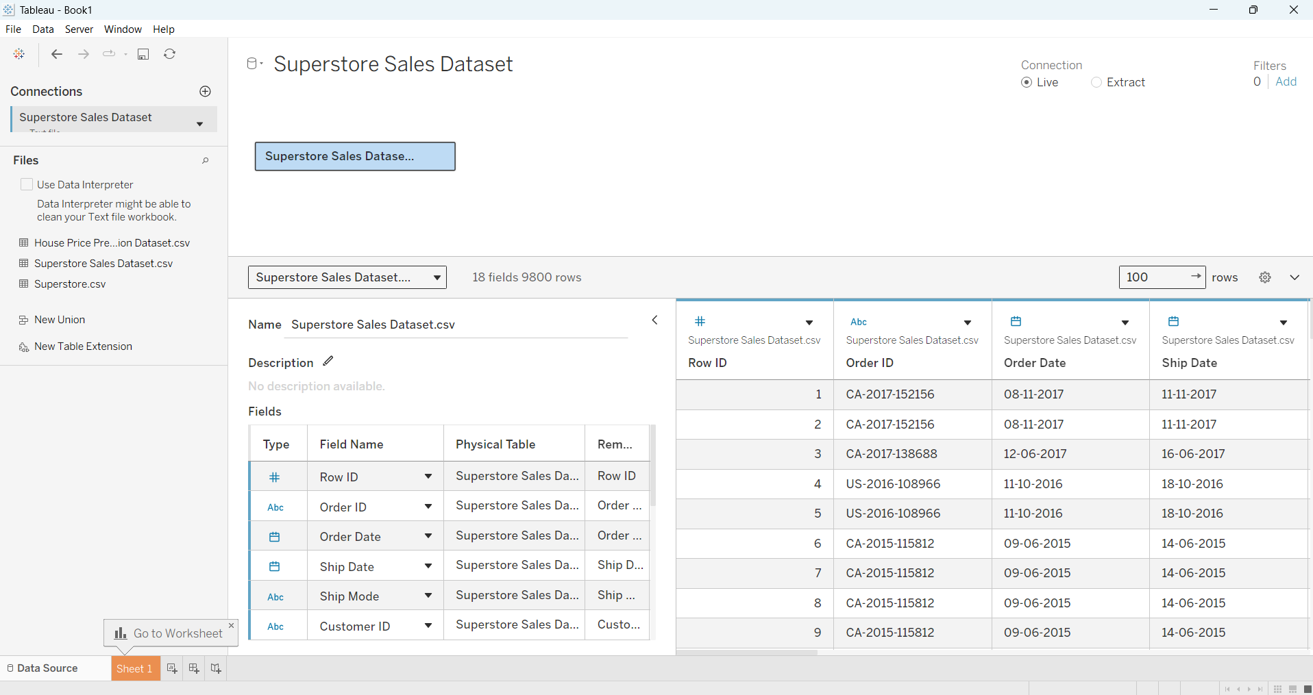
Figure 2: Data Source page after importing Superstore Sales Dataset.csv – showing 18 fields and 9,800 rows. Order Date and Ship Date are correctly recognized as Date type, Sales as Number
Step 3: Verify Data & Create Calculated Fields
Data quality was checked (no major missing values in key fields). The following calculated fields were created:
- Number of Orders: COUNTD([Order ID])
- Number of Customers: COUNTD([Customer ID])
- Average Order Value (AOV): SUM([Sales]) / COUNTD([Order ID])

Step 4: Create Key Performance Indicators (KPIs)
Four KPI cards were created on a dedicated worksheet using large text marks:
- Total Sales: $2,261,536.78
- Number of Orders: 4,922
- Number of Customers: 793
- Average Order Value: $459.48
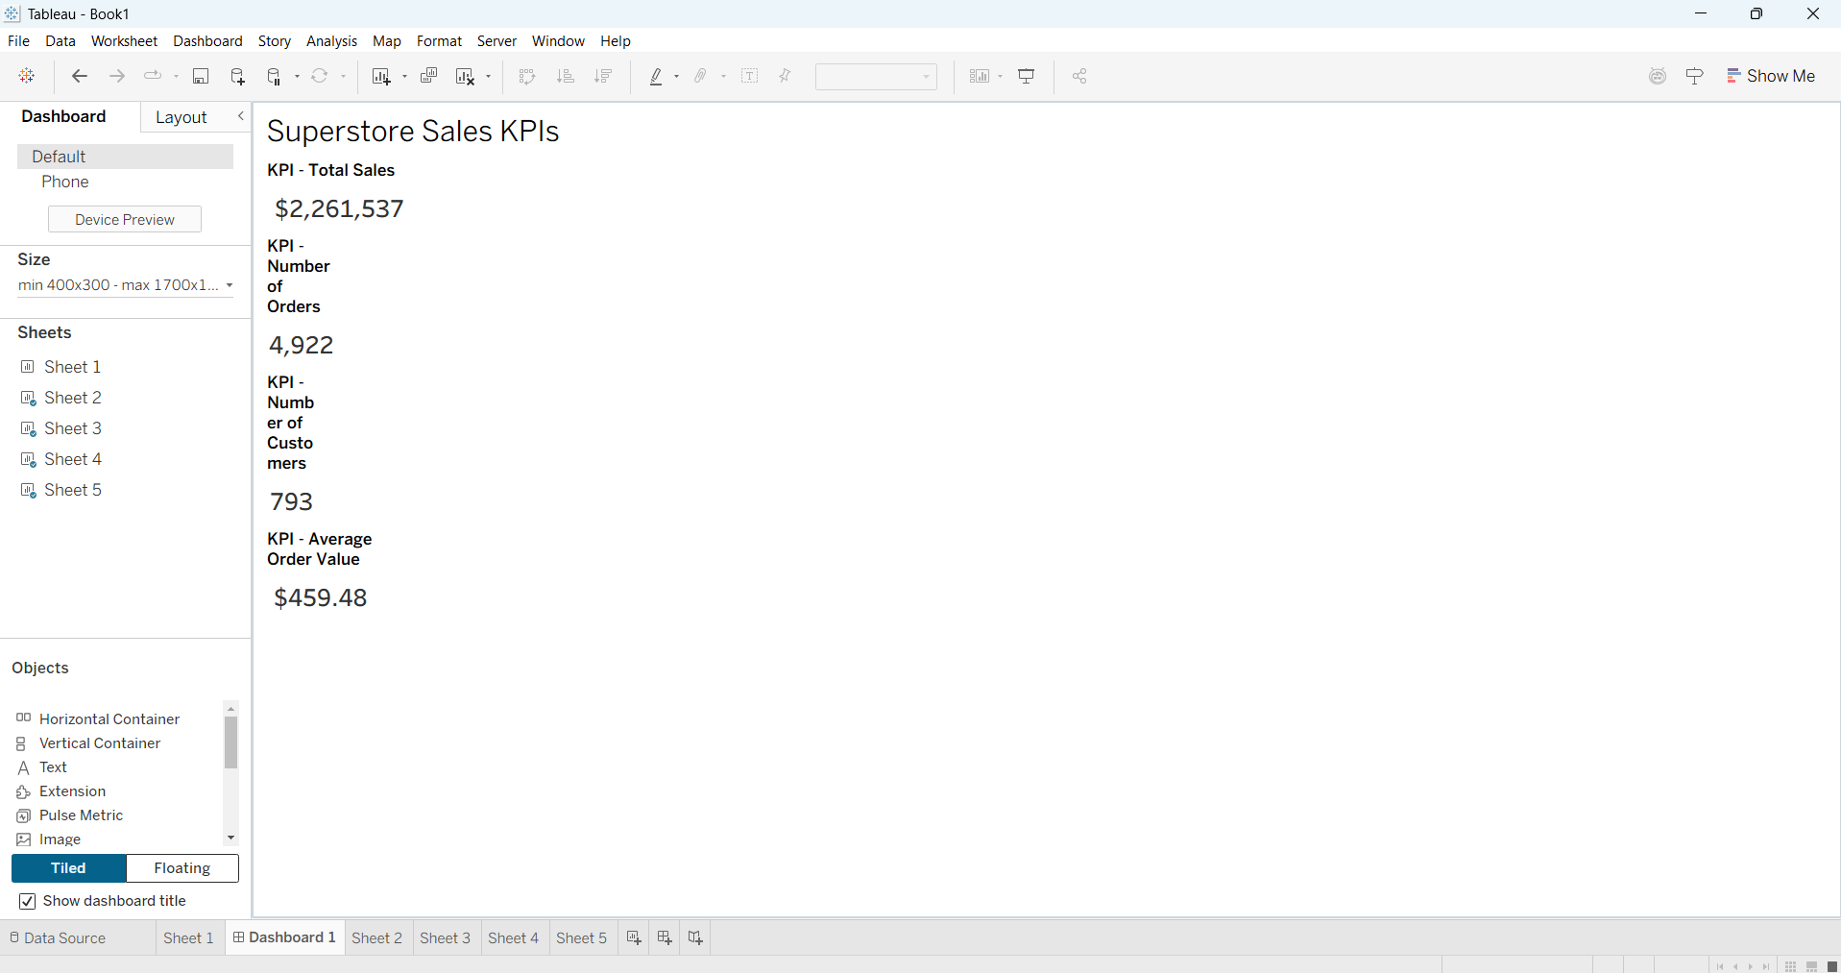
Figure 3: Key Performance Indicators (KPIs) – Total Sales ($2,261,537), Number of Orders (4,922), Number of Customers (793), and Average Order Value ($459.48)

Step 5: Develop Multiple Visualizations
The following charts were created on separate worksheets:
- Sales by Category – Horizontal bar chart. Technology leads ($827,456), followed by Furniture ($728,659) and Office Supplies ($705,422).
- Sales Trend over Time – Line chart using Order Date (Month/Year continuous).
- Sales by Region – Filled map of the United States. West is highest ($710,220), then East ($669,519), Central ($492,647), South ($389,151).
- Sales by Sub-Category – Treemap. Top contributors: Phones, Chairs, Storage, Tables, Binders.
- Sales by Segment – Pie / Donut chart. Consumer 50.8%, Corporate 30.4%, Home Office 18.8%.
- Top 10 Products by Sales – Sorted bar chart.
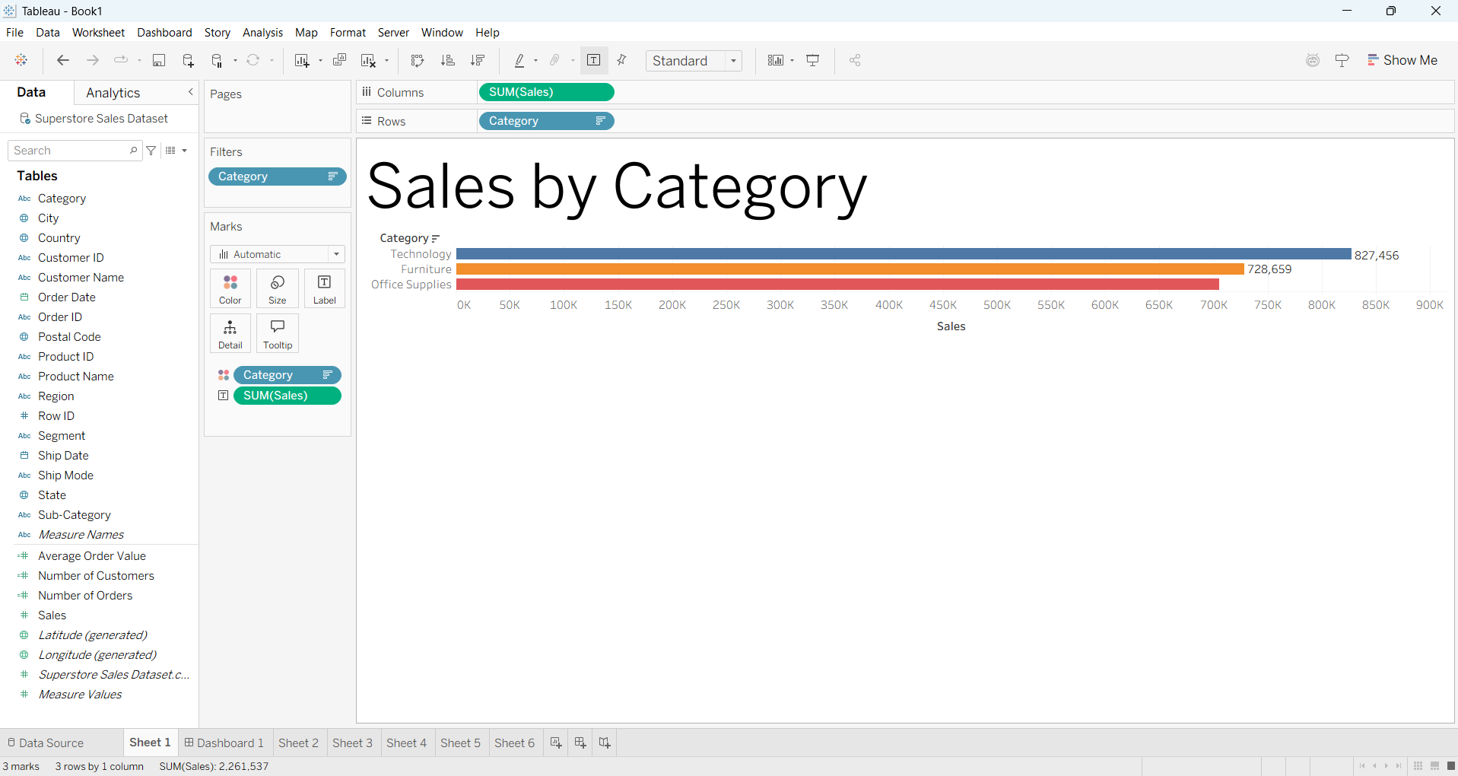
Figure 4: Sales by Category – Horizontal bar chart showing Technology as the highest revenue category.
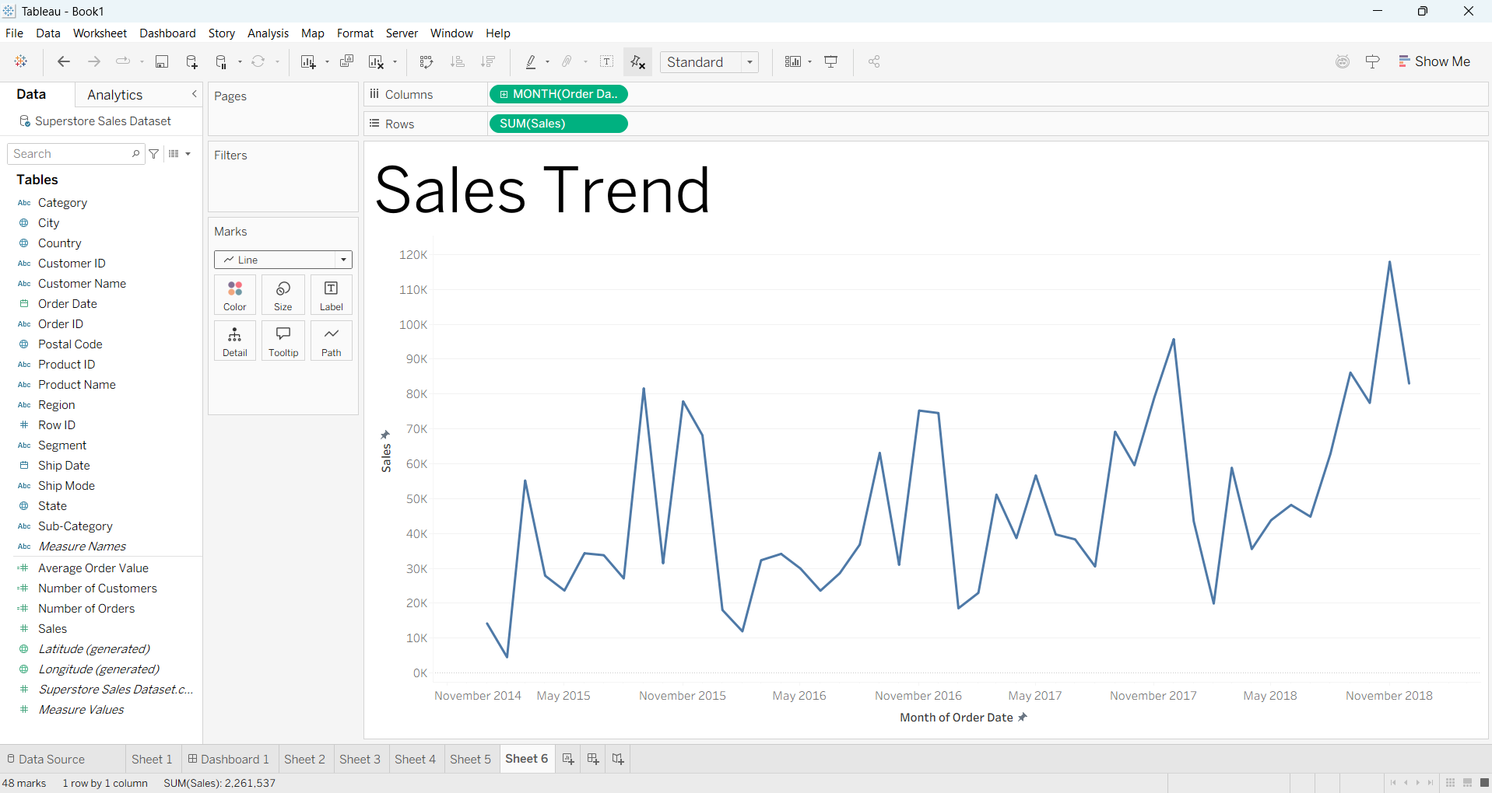
Figure 5: Sales Trend over Time – Line chart showing monthly sales performance.
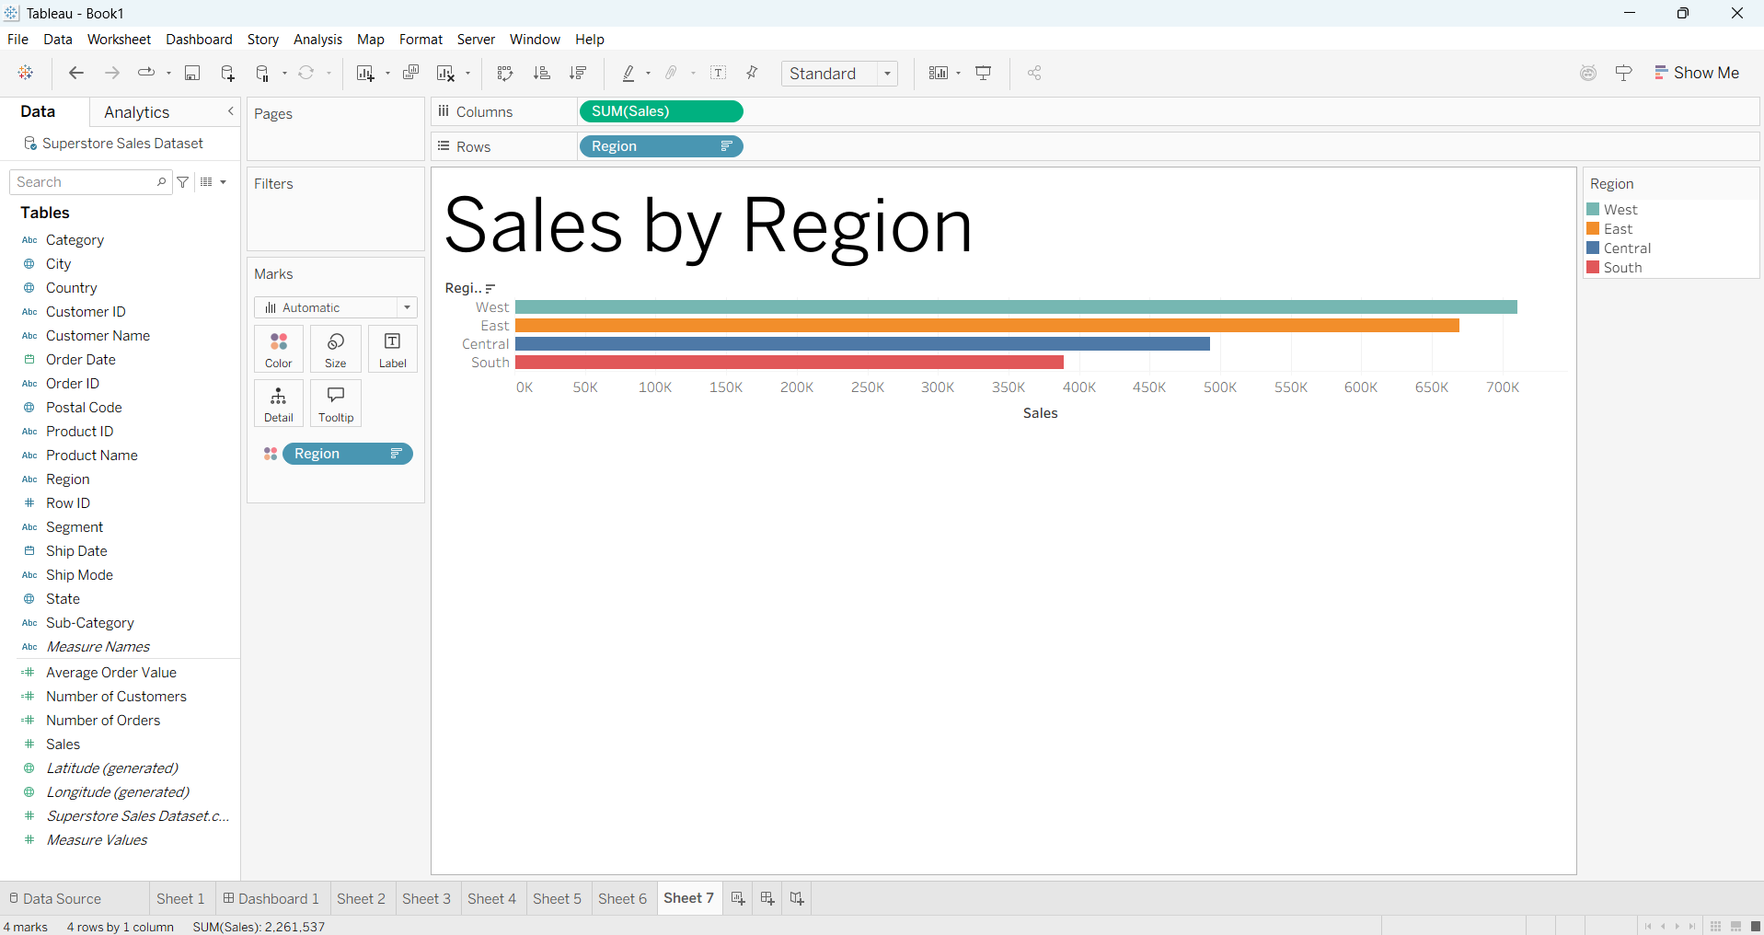
Figure 6: Sales by Region – Bar chart showing West region with the highest sales.
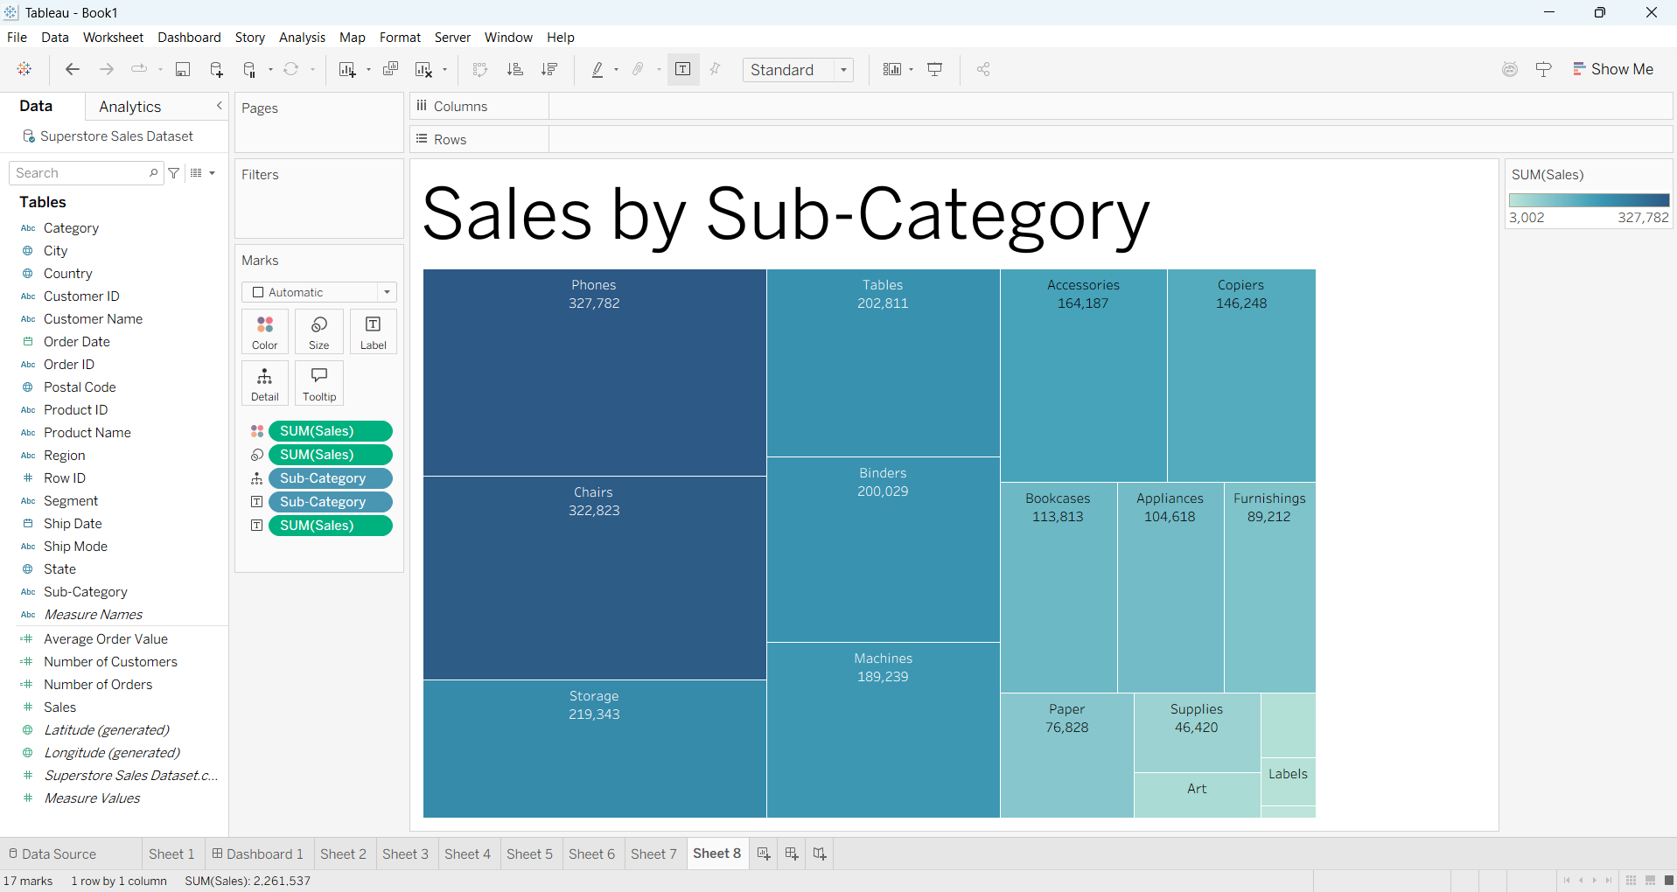
Figure 7: Sales by Sub-Category – Treemap showing top contributing sub-categories (Phones, Chairs, Storage, Tables, Binders).
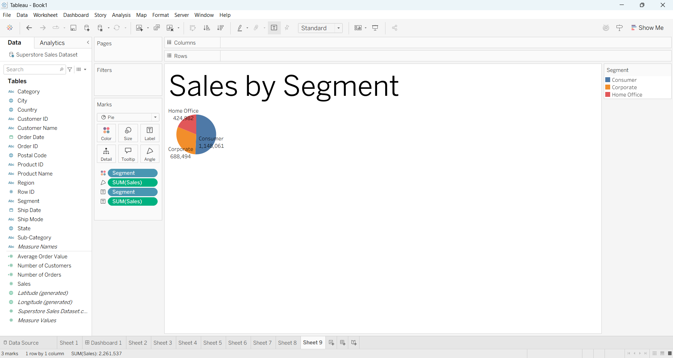
Figure 8: Sales by Segment – Pie chart showing Consumer segment contributing the highest sales.
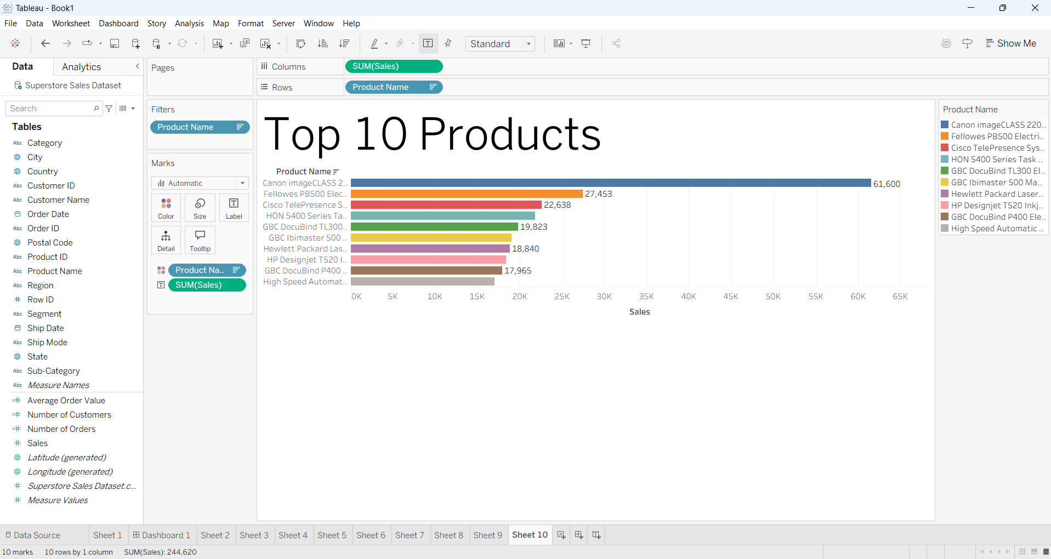
Figure 9: Top 10 Products by Sales – Sorted bar chart.
Step 6: Add Interactivity (Filters, Slicers, Drill-down)
Interactive controls added to the dashboard:
- Filter / Slicer on Region (West, East, Central, South)
- Filter on Category and Sub-Category
- Filter on Customer Segment
- Date Range filter on Order Date
- Filter and Highlight actions so that clicking a region, category, or segment updates all other visuals.
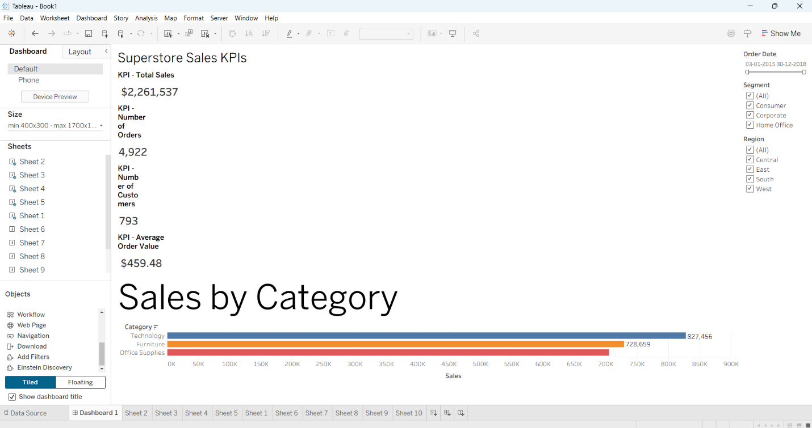
Figure 10: Interactive filters (Order Date, Segment, Region) placed on the right side of the dashboard.

Step 7: Arrange Professional Dashboard Layout
All worksheets were arranged on a single Dashboard (size approximately 1200 × 800). Title “Superstore Sales Performance Dashboard” was added at the top. KPI cards occupy the first row. Map and trend chart sit in the middle row. Category, Segment, and Sub-Category visuals are placed at the bottom. Consistent color scheme and clean formatting were applied. Tooltips were customized.
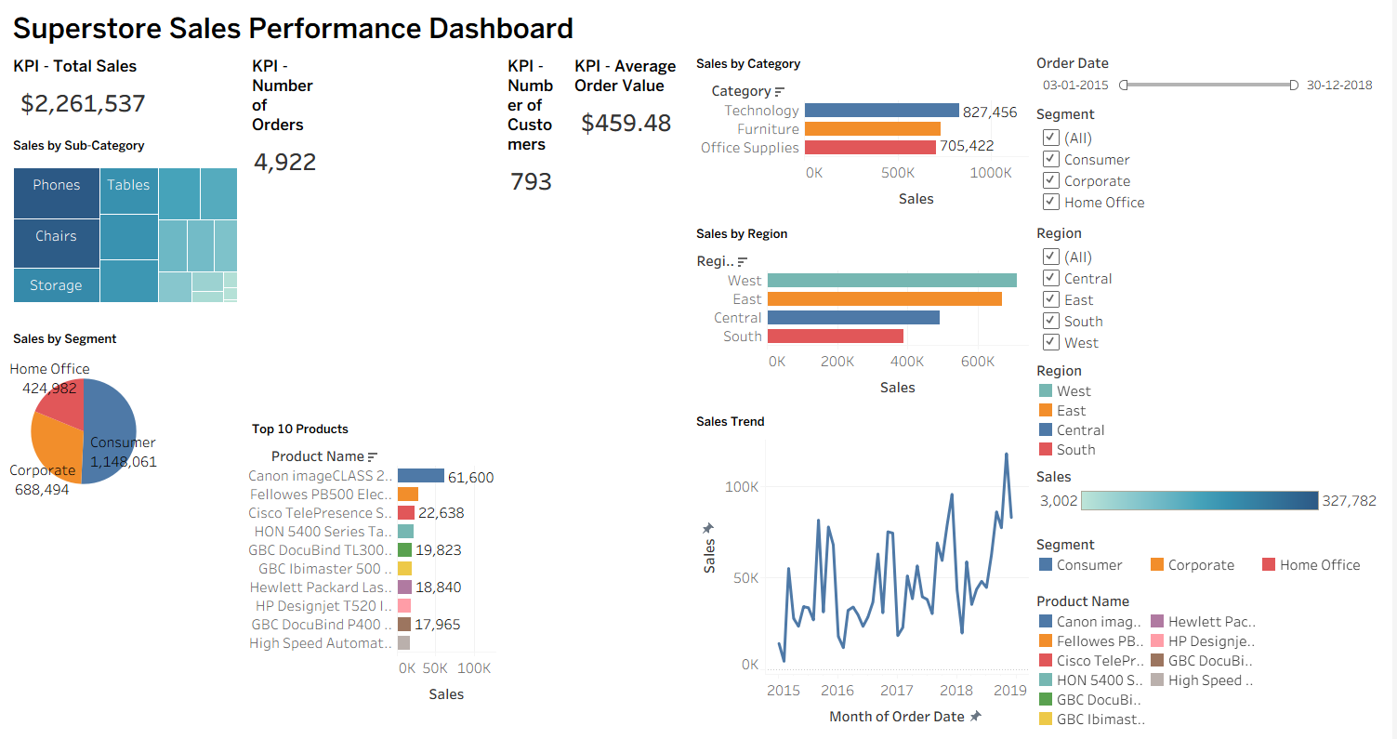
Figure 11: Final interactive dashboard – Superstore Sales Performance Dashboard showing KPIs, category/region/segment analysis, sales trend, and top products.

Step 8: Analyze the Dashboard – Key Insights
After exploring the interactive dashboard the following insights were obtained:
- Technology is the highest-revenue category ($827K), even though it has the fewest records.
- West region generates the most sales ($710K), followed closely by East.
- Consumer segment contributes more than half of total sales.
- Phones and Chairs are the two strongest sub-categories.
- Average Order Value is approximately $459 – useful for pricing and promotion decisions.

Step 9: Publish / Export the Dashboard
The completed dashboard was published to Tableau Public and also saved as a packaged workbook (.twbx). An image export was taken for this report.
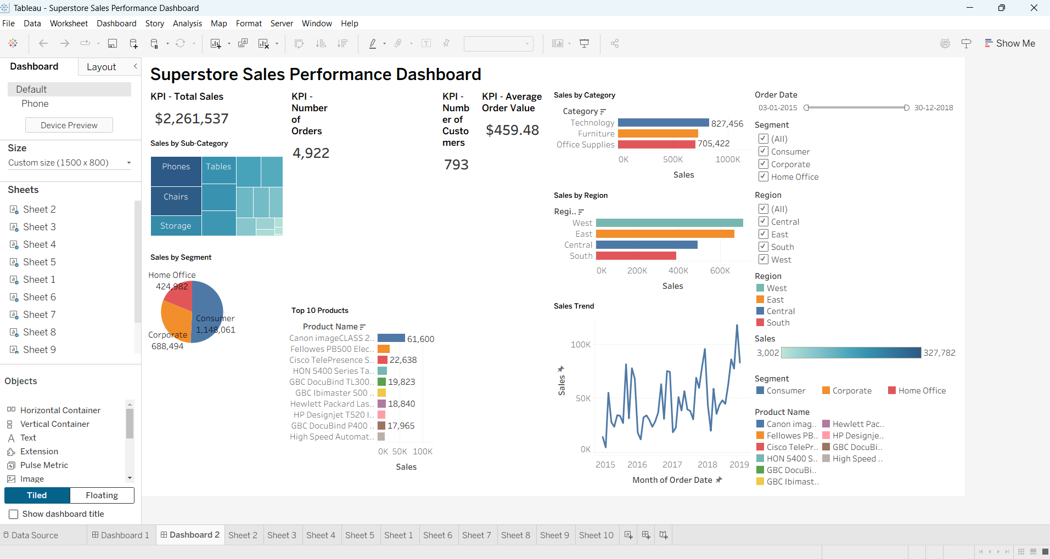
Figure 12: Published dashboard view on Tableau Public — Superstore Sales Performance Dashboard.

Step 10: Prepare Summary Report
This document serves as the brief report summarizing the key business insights obtained from the dashboard.

6. Observations & Key Business Insights
Using the actual Superstore Sales Dataset the following actionable insights were derived:
- High-performing areas: Technology category and West region drive the largest share of revenue.
- Customer base: 793 unique customers placed 4,922 orders, indicating good repeat-purchase potential.
- Segment focus: Consumer segment is dominant; Corporate and Home Office can be targeted with tailored campaigns.
- Product focus: Phones and Chairs are clear revenue leaders and should receive priority in inventory and marketing.
- Opportunity: South region has the lowest sales – further investigation into marketing or product mix is recommended.

7. Answers to Questions

Q1. What is Business Intelligence (BI)? How does it support organizational decision-making?
Business Intelligence (BI) is a set of processes, technologies, and tools that collect, analyze, and present business data in the form of reports, dashboards, and visualizations. BI transforms raw data into actionable insights. It supports organizational decision-making by providing managers with timely, accurate, and easy-to-understand information about past performance, current status, and emerging trends, enabling fact-based decisions instead of intuition.

Q2. What is an interactive dashboard? How is it different from a static report?
An interactive dashboard is a visual interface that displays multiple charts, KPIs, and metrics on a single screen and allows the user to filter, drill down, highlight, and explore the data dynamically. A static report (PDF or printed chart) shows fixed information that cannot be changed by the viewer. An interactive dashboard lets the user change filters and instantly see updated visuals, enabling deeper self-service analysis.

Q3. Compare Tableau and Microsoft Power BI based on features, usability, and business applications.
Both are leading BI tools:
Aspect | Tableau | Power BI
Features | Excellent visual analytics, strong mapping, advanced calculations | Tight Microsoft integration, AI visuals, strong data modeling (DAX)
Usability | Very intuitive drag-and-drop interface | Familiar to Excel users; steeper curve for advanced DAX
Business Use | Executive dashboards, data storytelling, public visualizations | Microsoft-centric organizations, finance & enterprise reporting
Cost | Tableau Public free; Desktop & Server paid | Desktop free; Pro/Premium with Microsoft 365

Q4. What are Key Performance Indicators (KPIs)? Give examples of KPIs used in sales analytics.
Key Performance Indicators (KPIs) are quantifiable metrics that measure how effectively an organization is achieving its key business objectives.
Examples used in this sales dashboard:
- Total Sales / Revenue
- Number of Orders
- Number of Customers
- Average Order Value (AOV)

Q5. Explain the purpose of filters, slicers, and drill-down functionality in dashboards.
Filters: Restrict the data displayed (e.g., show only West region).
Slicers: Visual, user-friendly filter controls placed on the dashboard itself.
Drill-down: Move from high-level summary (Category) to detailed levels (Sub-Category → Product) for hierarchical exploration.

Q6. What factors should be considered while designing an effective business dashboard?
- Clarity of purpose and audience
- Selection of the most important KPIs – avoid clutter
- Logical layout (KPIs at top, detailed charts below)
- Consistent colors, fonts, and formatting
- Meaningful interactivity without overwhelming the user
- Fast performance and clear tooltips

Q7. How can dashboards help managers monitor organizational performance in real time?
Modern BI dashboards can be connected to live or frequently refreshed data sources. Managers open a single screen and instantly see current sales, order volume, regional performance, etc. Conditional formatting and alerts highlight exceptions, allowing quick reaction instead of waiting for static weekly reports.

Q8. Why is data visualization important in Business Intelligence tools?
The human brain processes visual information far faster than tables of numbers. Charts, maps, and KPI cards reveal patterns, trends, and outliers that are hard to spot in raw data. Good visualization reduces cognitive load, improves understanding across technical and non-technical stakeholders, and accelerates decision-making.

Q9. What insights can be derived from a sales dashboard for an e-commerce company?
- Which products / categories generate the most revenue
- Geographic performance (best and weakest regions)
- Customer segment contribution
- Average Order Value and order volume trends
- Seasonal patterns and opportunities for targeted campaigns

Q10. Explain how interactive dashboards improve communication between data analysts and business stakeholders.
Interactive dashboards act as a common language. Analysts build a self-service tool once; stakeholders explore the data themselves by applying filters and drill-downs without repeatedly requesting new reports. This reduces back-and-forth, builds trust in the data, enables faster answers to ad-hoc questions, and allows meetings to focus on decisions rather than data explanation.

8. Conclusion
In this experiment an interactive Superstore Sales dashboard was successfully designed and developed using Tableau Public and the provided Superstore Sales Dataset (9,800 records). The dashboard presents accurate KPIs (Total Sales $2.26 M, 4,922 Orders, 793 Customers, AOV $459) together with multiple visualizations (bar, line, map, treemap, pie) and interactive filters. Analysis revealed that Technology and the West region are the strongest performers, while the Consumer segment dominates sales. The exercise demonstrated how BI tools transform raw transactional data into actionable visual insights that support data-driven decision-making.

9. References
- Tableau Public Official Website – https://public.tableau.com
- Superstore Sales Dataset.csv (provided for this experiment)
- Tableau Desktop / Public User Guide and Online Help
- Business Intelligence concepts – standard industry definitions

